****Project objective:****

As a developer, fix the bugs in the application using the appropriate algorithmic techniques.

****Background of the problem statement:****

You have been assigned a few tasks during the sprint planning. Solving the bugs raised by the testing team is one among them. You are given the boilerplate code and are asked to complete it by fixing the bugs

**Source Code :-**

**import** java.util.ArrayList;

**import** java.util.Collections;

**import** java.util.Scanner;

**public** **class** FixBugsoftheApplication {

**public** **static** **void** main(String[] args) {

System.***out***.println("Welcome to Simplilearn \n");

System.***out***.println("************");

*optionsSelection*();

}

**private** **static** **void** optionsSelection() {

String[] arr = {"1. I wish to review my expenditure",

"2. I wish to add my expenditure",

"3. I wish to delete my expenditure",

"4. I wish to sort the expenditures",

"5. I wish to search for a particular expenditure",

"6. Close the application"

};

**int**[] arr1 = {1,2,3,4,5,6};

**int** slen = arr1.length;

**for**(**int** i=0; i<slen;i++){

**for**(**int** j=1;j<=slen;j++){

**if**(options==j){

System.***out***.println(arr[i]);

}

ArrayList<Integer> arrlist = **new** ArrayList<Integer>();

ArrayList<Integer> expenses = **new** ArrayList<Integer>();

expenses.add(1000);

expenses.add(2300);

expenses.add(45000);

expenses.add(32000);

expenses.add(110);

expenses.addAll(arrlist);

System.***out***.println("\nEnter your choice:\t");

Scanner sc = **new** Scanner(System.***in***);

**int** options = sc.nextInt();

**switch** (options){

**case** 1:

System.***out***.println("Your saved expenses are listed below: \n");

System.***out***.println(expenses+"\n");

*optionsSelection*();

**break**;

**case** 2:

System.***out***.println("Enter the value to add your Expense: \n");

**int** value = sc.nextInt();

expenses.add(value);

System.***out***.println("Your value is updated\n");

expenses.addAll(arrlist);

System.***out***.println(expenses+"\n");

*optionsSelection*();

**break**;

**case** 3:

System.***out***.println("You are about the delete all your expenses! \nConfirm again by selecting the same option...\n");

**int** con_choice = sc.nextInt();

**if**(con_choice==options){

expenses.clear();

}

*optionsSelection*();

System.***out***.println(expenses+"\n");

System.***out***.println("All your expenses are erased!\n");

} **else** {

System.***out***.println("Oops... try again!");

**break**;

**case** 4:

*sortExpenses*(expenses);

*optionsSelection*();

**break**;

**case** 5:

*searchExpenses*(expenses);

*optionsSelection*();

**break**;

**case** 6:

*closeApp*();

**break**;

**default**:

System.***out***.println("You have made an invalid choice!");

**break**;

}

}

}

}

**private** **static** **void** closeApp() {

System.***out***.println("Closing your application... \nThank you!");

}

**private** **static** **void** searchExpenses(ArrayList<Integer> arrayList) {

**int** leng = arrayList.size();

System.***out***.println("Enter the expense you need to search:\t");

Scanner sc = **new** Scanner(System.***in***);

**int** input = sc.nextInt();

**for**(**int** i=0;i<leng;i++) {

**if**(arrayList.get(i)==input) {

System.***out***.println("Found the expense " + input + " at " + i + " position");

}

}

}

**private** **static** **void** sortExpenses(ArrayList<Integer> arrayList) {

**int** arrlength = arrayList.size();

Collections.*sort*(arrayList);

System.***out***.println("Sorted expenses: ");

**for**(Integer i: arrayList) {

System.***out***.print(i + " ");

}

System.***out***.println("\n");

}

}

**Output :-**

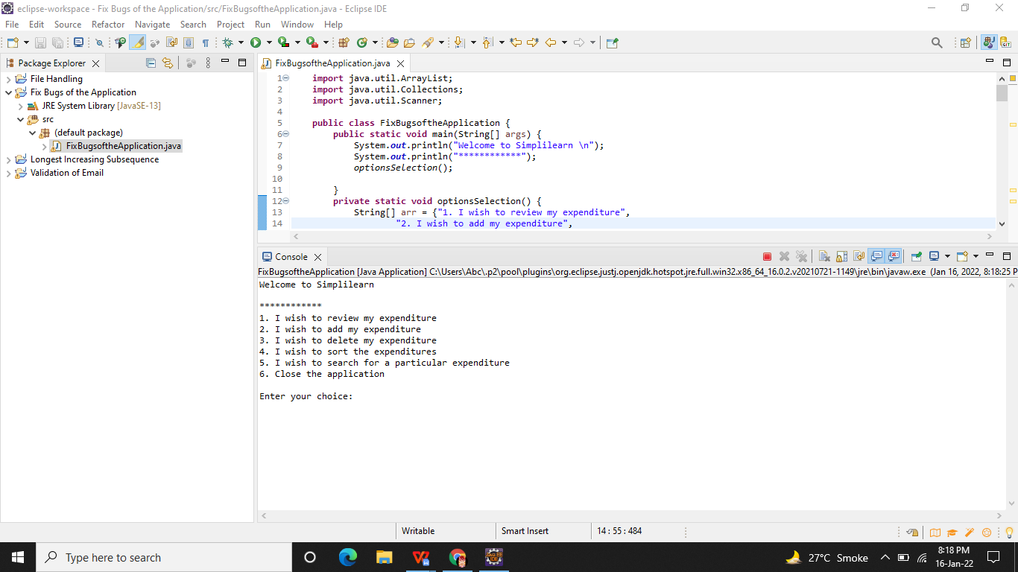

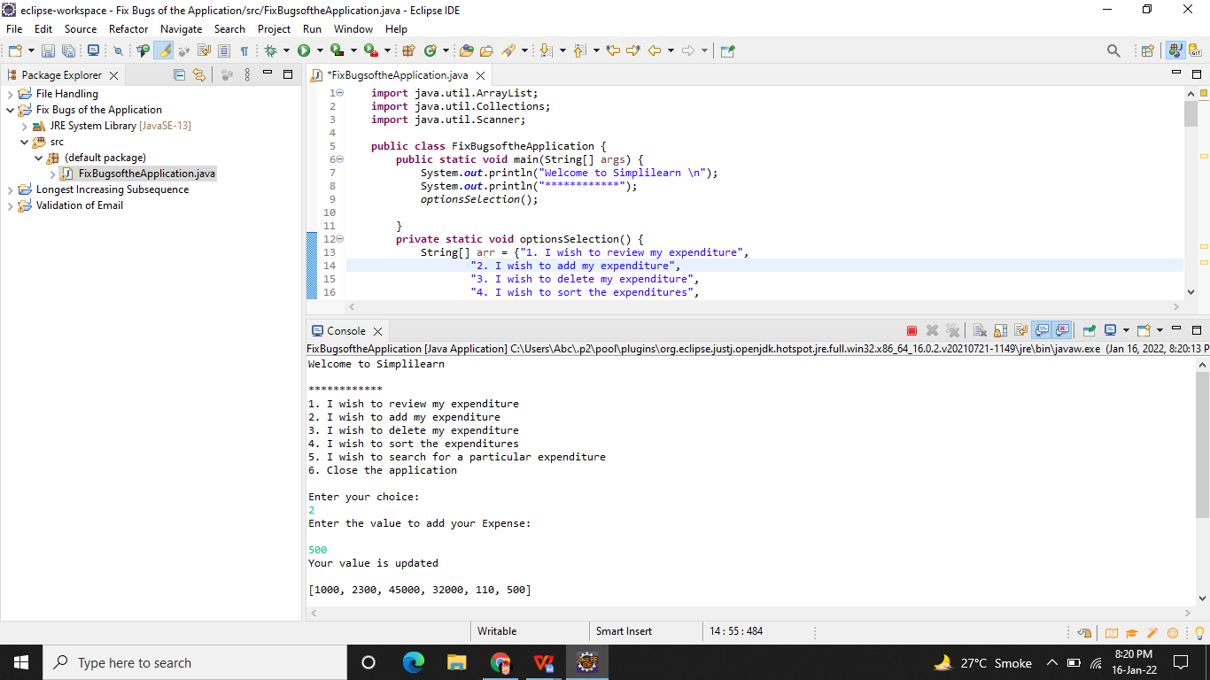

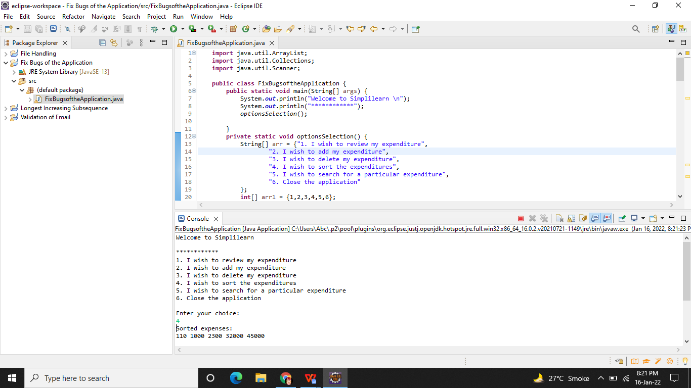

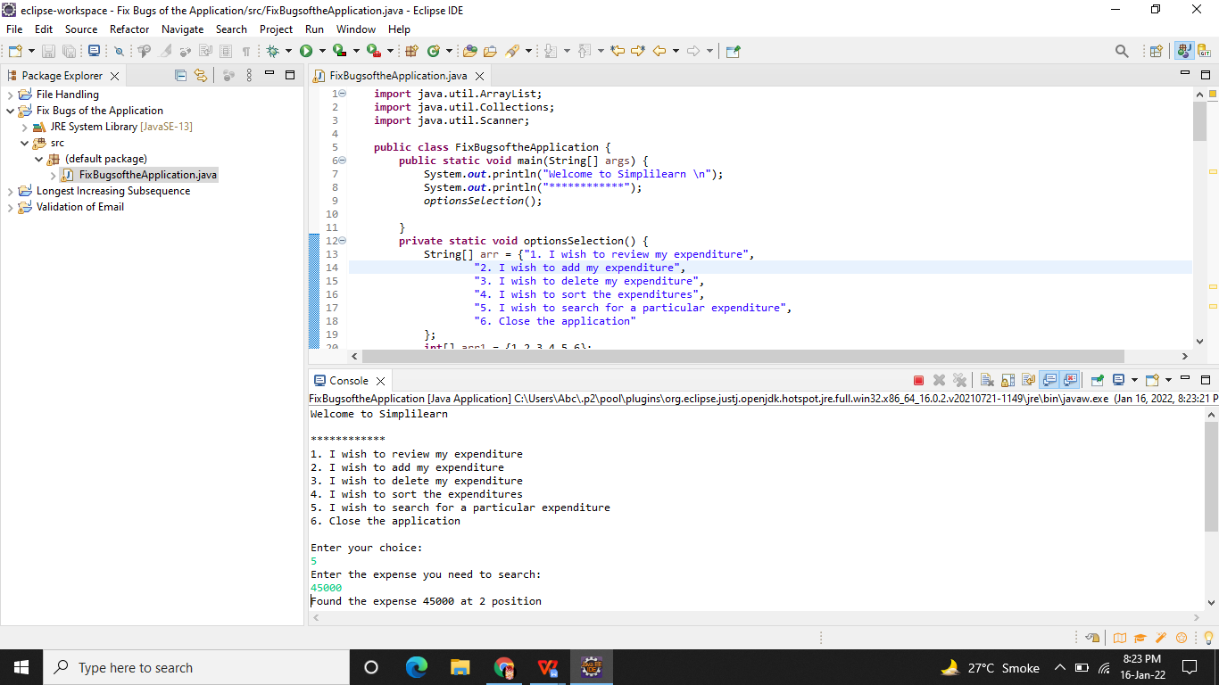

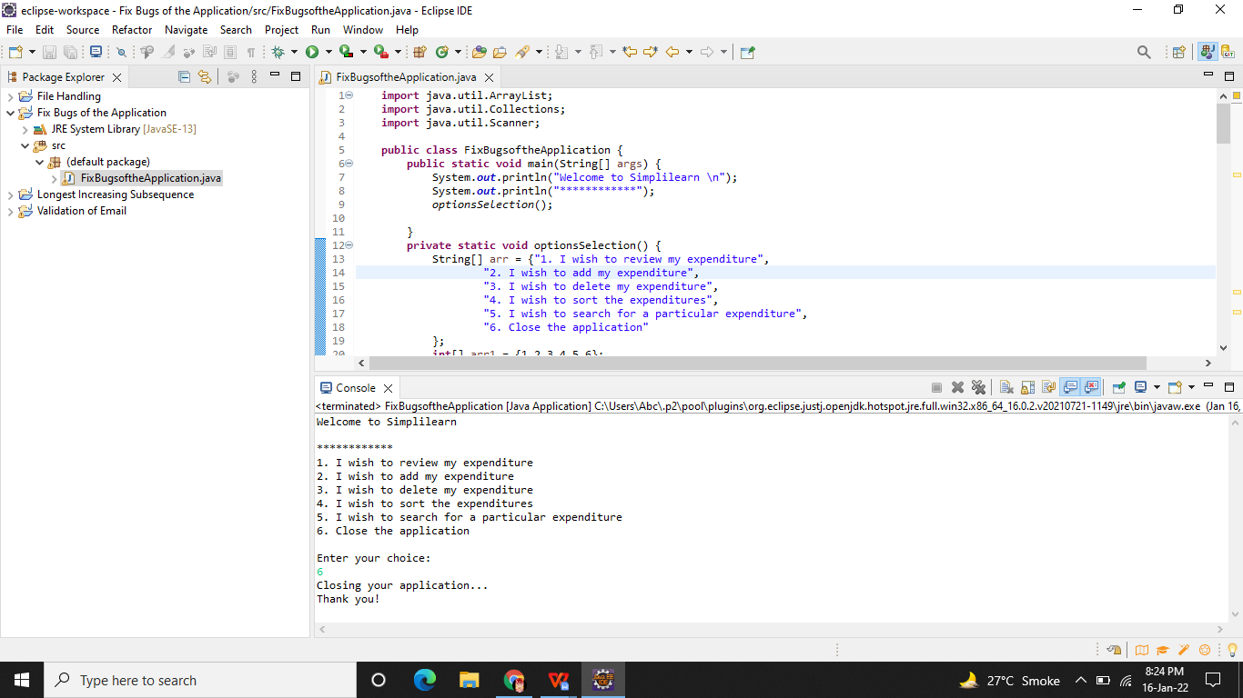

**Github Link -**

**https://github.com/Aniket03-op/Project.git**